**EXERCISE 2-DDL Commands with Constraints – PRIMARY, FOREIGN KEY, UNIQUE, CHECK**

**Q1**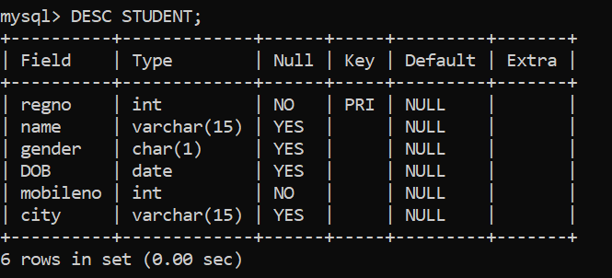

**Q2**

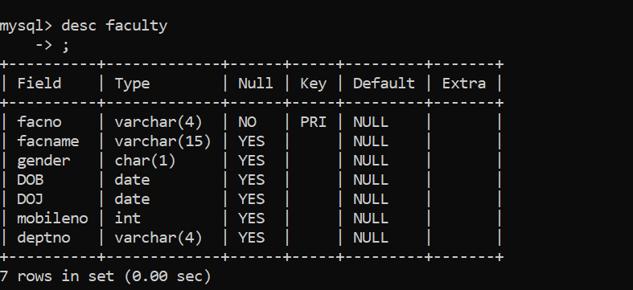

Q4

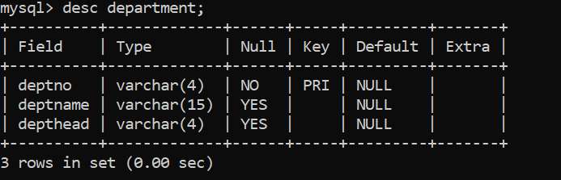

Q5